Import Data using Transform Maps (Spreadsheet)
Phase 5: Project Development Phase

1. Overview
The development phase implements the planned ServiceNow workflow. A spreadsheet containing sample employee data is prepared and loaded using Load Data. The Employee Test target table and its fields are configured.
The Employee Import staging table and Sample Spreadsheet Import Transform Map are then created. Source and target fields are mapped, the data is transformed, and the resulting records are verified. Coalesce is configured to handle existing employee records. Reports for department, location and employee lists are also created and added to the dashboard.

2. Key Activities
- Prepare and download the spreadsheet.
- Create Employee Test and its fields.
- Create Employee Import.
- Create Sample Spreadsheet Import Transform Map.
- Map source and target fields.
- Run Transform.
- Enable Coalesce.
- Create three reports.
- Create Employee Analytics Dashboard.
3. Detailed Process
In this phase, the project work related to **Project Development Phase** is carried out according to the overall ServiceNow project workflow. The activities are recorded in sequence so that the implementation can be understood and demonstrated clearly.

4. Expected Outcome
The phase should produce a clear and documented output that can be verified before moving to the next phase. The project remains focused on importing spreadsheet employee data into ServiceNow using Import Sets and Transform Maps.

5. Project Evidence / Screenshots
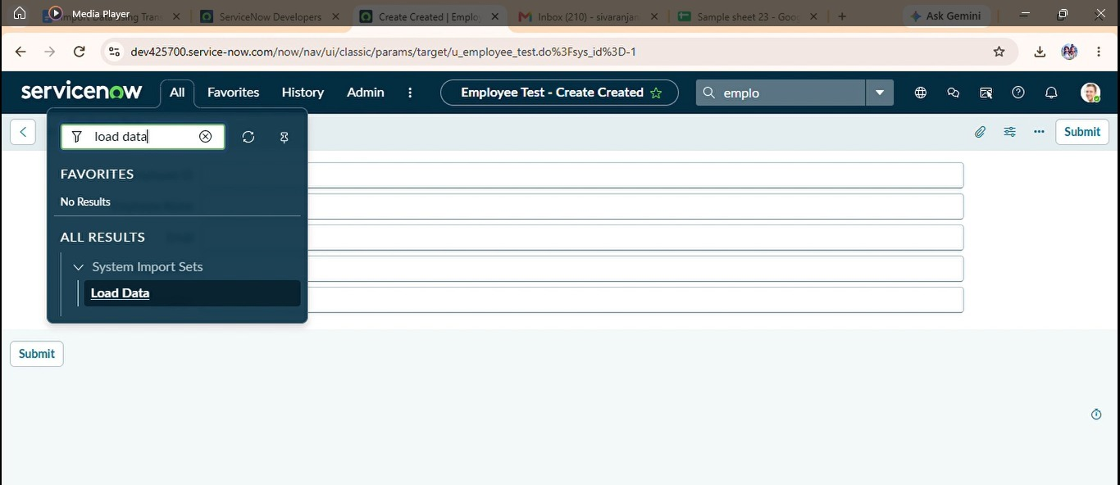

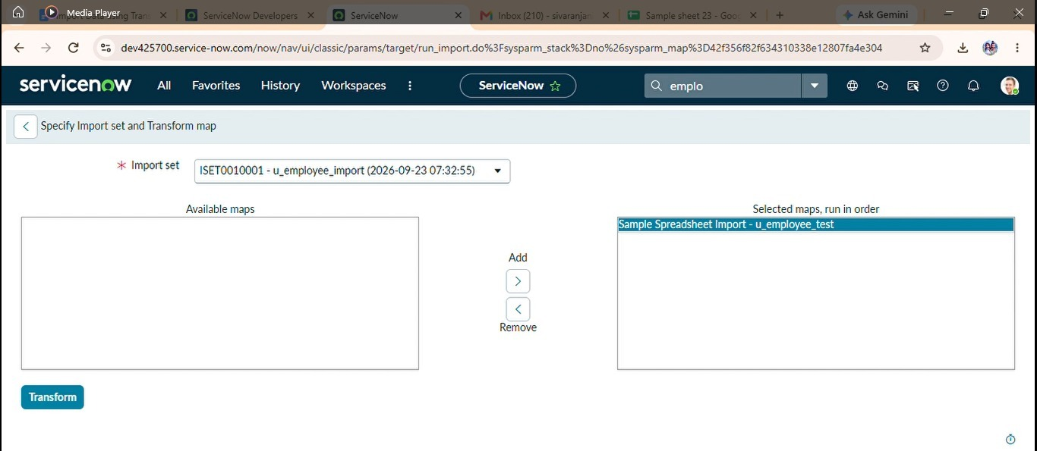

6. Phase Summary
Phase 5 completes the activities required for Project Development Phase. The documented output and screenshots provide evidence of the project work and support the transition to the next phase.

